Celebration of Worship
August 5, 2018
_________________________________________________________________________________________

Gather – Assemble in God’s Name
_________________________________________________________________________________________

Prelude
Please silence phones.
*Those who are able, please stand.

The Chiming of the Hour

Welcoming and Sharing of Community Life

Call to Worship
One: Let us come before God to receive the Lord’s Blessing.
Many: Let us come willing to be challenged.
One: Let us come expecting to be changed.
Many: Let us come ready to be encouraged.

*Hymn of Praise #464
“Joyful, Joyful, We Adore Thee”

*Prayer of Confession (In Unison)
We confess, Lord God, that we sometimes deal with
issues of trust. We are not always entirely convinced
that you care for us and love us. We sometimes
question your providences. We’re not always sure
that you answer our prayers, and we sometimes feel
very much alone. Help us, Lord God, to think of you
as our heavenly parent, and give us the peace and
confidence of children of God.

*A Time for Silent Confession

*The Assurance of Forgiveness
One: Friends, Believe the good news of the gospel.
Many: In Jesus Christ we are forgiven.

*Response of Praise and Gratitude

“Gloria Patri”
Glory be to the Father, and to the Son,
and to the Holy Ghost; as it was in the
beginning, is now and ever shall be,
world without end. Amen, Amen.

*Passing of the Peace

Joys and Concerns of the Church

(Please sign the fellowship register than pass it to your neighbor and return. Thank you.)

__________________________________________________________________________________________

Grow – Proclaim God’s Word
__________________________________________________________________________________________

Children’s Message

Gospel Lesson:
John 6:24-35 Page 867

Choral Anthem: “The Healer”
Words & Music: Lois Irwin
Arr: Harold DeCou

Message: “Healing Grace”
John T. Wamsley

Affirmation of Faith (In Unison)

“The Apostles’ Creed” #14

*Hymn
“Here, O Our Lord, We See You Face to Face” #520

Offertory

__________________________________________________________________________________________

Give Thanks to God
__________________________________________________________________________________________

Sacrament of the Lord’s Supper

Invitation to the Lord’s Table
Prayers of the People & the Lord’s Prayer
Service of the Holy Communion

(Please hold the elements until all have been served.)

__________________________________________________________________________________________

Go – In God’s Name
__________________________________________________________________________________________

*Hymn:
“May the Lord, Mighty God” #596

May the Lord, Mighty God, bless and keep you forever,
Grant you peace, perfect peace, courage in every
endeavor.
Lift up your eyes and see God’s face, full of grace
forever.
May the Lord, Mighty God, bless and keep you forever.

*The Charge and Benediction

*Postlude

***************************************************
Sam Andreu (Elder of the Month) 209-1761

Ernest McNeill (Assistant Elder of the Month) 209-1919
***************************************************

To Our Guests:
We are happy to have you worship with us today. We invite you to join us each Sunday, as we worship and study God’s word. If you would like more information concerning our Church, you may fill out one of the Welcome Cards in the pews and place it in the offering plate, talk to the ushers, call the church office at 850-526-2430 or email us at fpcmarianna@gmail.com.

Nursery Care: Available for children six years old and under during the worship service each Sunday morning.

The Flowers today are given to the Glory of God by Jason and LuAnne Law and in honor of Mary Lu Andreu for her work with the children of our church.

This Week In Our Church:

Today August 5th
9:30 am Coffee & Juice Fellowship
9:45 am Sunday School
10:30 am Choir Rehearsal
11:00 am Worship Service (Communion)
Tuesday August 7th
3:30 pm Food Pantry Bagging
4:00 pm Chipola Area Autism (Teen Social Skills)
Wednesday August 8th
7:45 am Playground*
9:00 am Youth Choir*
9:00 am Food Pantry
4:30 pm Choir Rehearsal
6-7 pm Back to School Prayer at Citizen’s Lodge
Thursday August 9th
4:00 pm Alzheimer’s Meeting
7:00 pm NA Meeting
Friday August 10th
5:30 pm Grief & Memorial Ceremony for Children
followed by lighting of lanterns at Madison
Park

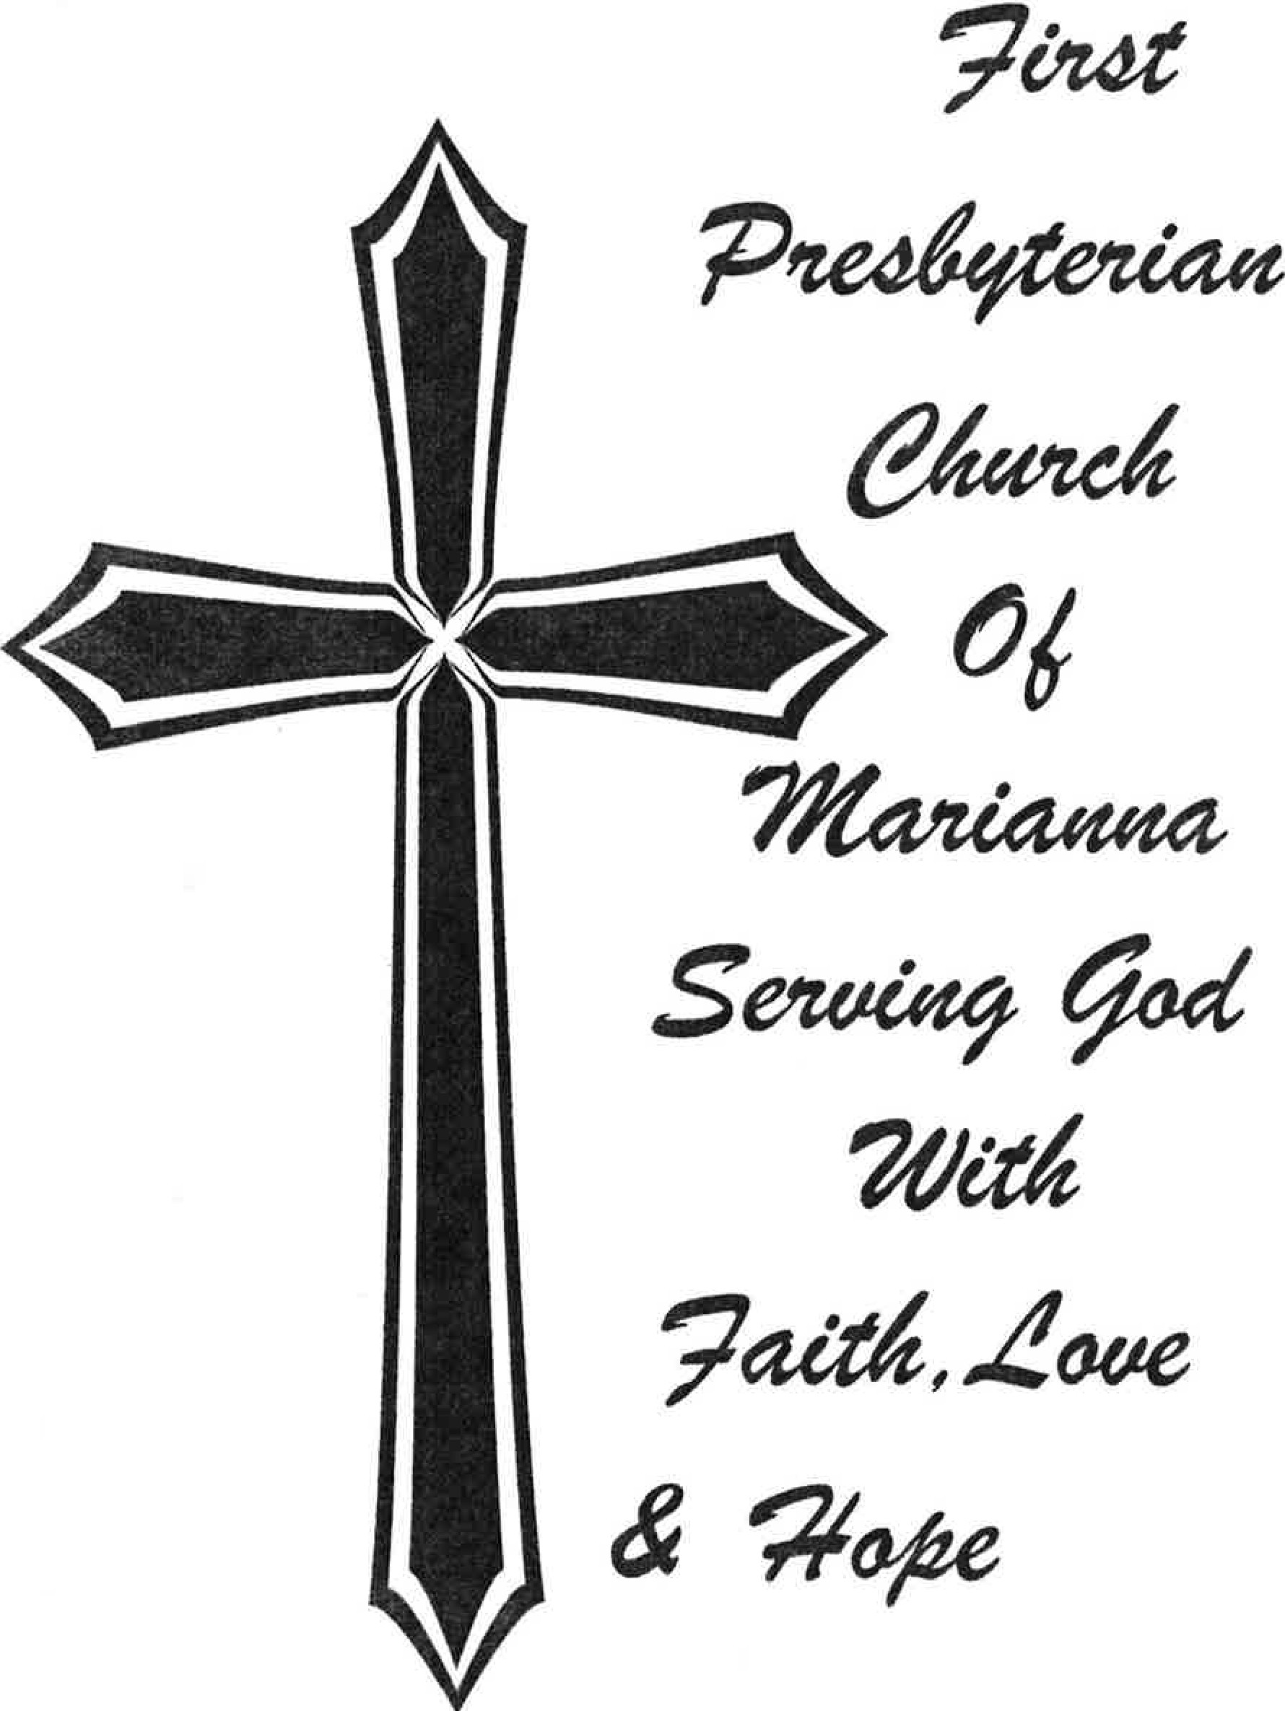
First Presbyterian Church Prays For:
(New requests in bold)

Kay Trammell (Robert Trammell’s wife)
Jeanne Cowen
George Berquist (Jill Berquist’s father)
Joel Gulledge (Gayle DeBenedetto’s son-in-law)
Roy Turner
Michael Andrejko (Mary Wierman’s brother)
Shirley Pitts (Susie Barber’s sister)
Jean Sims (requested by Ouida Morris)
Pat Furr (requested by Ouida Morris)
Steve Stafford (Barry’s dad)
Billy Herrington (requested by Jared Roberts)
Greg Barber (Cindy Yant’s brother)
Gina Stuart
Don Morris
David Sims
Lou Roberts
Wayne Barber (requested by Amanda Hinson)
Robert Hinson (requested by Beverly Hinson)
Dorothy Baxter (requested by Susie Stevens)
Brent Bedini
Howard Alig (Cindy Morgan’s brother)
Steven Quigley
Hunter and Lu Daffin
Ray Windham (requested by Cecil Powell and
Bev Kilmer)
Elizabeth Walker (Stan Littleton’s sister)
Linda Bevis (requested by Mary Bevis Schmidt
Matt Goold (requested by family)
Sybil Schmidt King (requested by Mary B. Schmidt)
Gail Stearn, (Guy Green’s sister)
Destry Burch (requested by Mary B. Schmidt)
Marie Lanier (requested by Joy Lewis)
Ginny Rose, Brooke Grant, Malaki Grant
(Family of Carol and Dennis Maxson)
***************************************************
Summer Youth Choir – On August 8th and 15th at 4:30 pm the Children’s Choir will have practice in the sanctuary to prepare for their performance on Rally Day, August 19th at 9:30 am.

Breakfast on Rally Day – On August 19th at 8:30 am the Men of the Church (“God’s Warriors”) will serve breakfast.
On this day you will have the opportunity to hear about all of the offerings for Spiritual growth and Service and Fellowship that our Church provides.

Ladies Fall Gathering – August 20th at 6 pm. All Women and Circles join together on this evening.
***************************************************

SINCE 1835

2898 Jefferson Street
Marianna, FL 32446
Phone (850) 526-2430
fpcmarianna@gmail.com
www.firstpresmarianna.org

