Celebration of Worship
December 16, 2018

_________________________________________________________________________________________

Gather – Assemble in God’s Name
_________________________________________________________________________________________

Prelude
Please silence phones.
*Those who are able, please stand.

The Chiming of the Hour

Welcoming and Sharing of Community Life

The Third Sunday of Advent: Joy

Call to Worship
Leader: Today is the third Sunday of Advent, the Sunday
of Joy.
People: Our Joy is in God and in His Son, Jesus Christ.
Like peace, joy is a gift from God. It overtakes
us and fills us when we remember what God has
done and what He has promised to do.

We light this candle today to remind us that Christ came and
is coming so that all people might have a rich and abundant
life. We thank God for the hope he gives us, for the peace
He bestows, and for the joy He pours into our hearts.

Light the First, Second and Third Candles

All: Let us pray:
O God of Joy, Emmanuel, send your light into our hearts
at this time. Help us to be ready for the time of Christ’s
appearing. Fix our hearts and our minds upon those things
you have done and those you have promised to do that we
may have the joy you have promised. As we worship you,
strengthen us so that we may always do your will and so
bless you and the world you have made. Amen.

*Hymn of Praise #???
“Lord Christ, When First You Came to Earth”

OFFICE TORN APART FOR NEW CARPET
DID NOT FINISH THIS!!!!
*Prayer of Confession (In Unison)
During this season of Advent we confess that in our
Christmas preparations there is more of culture than of
Christ. We allow the noise and confusion of the season
to obscure the peace we have with you. We allow the
raucous jingles of commerce to distract us from the pro-
found mystery of Bethlehem. We allow material and
financial considerations to overpower spiritual realities.
Forgive us, we pray and draw us back to the quiet
presence of the living Christ.

*A Time for Silent Confession

*The Assurance of Forgiveness
One: Friends, Believe the good news of the gospel.
Many: In Jesus Christ we are forgiven!

*Response of Praise and Gratitude

“Gloria Patri” #581
Glory be to the Father, and to the Son,
and to the Holy Ghost; as it was in the
beginning, is now and ever shall be,
world without end. Amen, Amen.

__________________________________________________________________________________________

Grow – Proclaim God’s Word
__________________________________________________________________________________________

Scripture Lesson:
Zephaniah 3:14-20 Page #???

Choral Anthem “Prepare the Way”
Words by: Frans Michael Franzen???
Music by: ???Swenska Psalmoboken????
Arr. by: Jesse Benton

Message: “All I Want for Christmas is Joy”
John T. Wamsley

*Statement of Christian Beliefs (In Unison)
We affirm that Jesus was born of woman
as is every child, yet born of God’s power
as was no other child.
In the person and work of Jesus, God himself and
a human life are united but not confused,
distinguished but not separated.
The coming of Jesus was itself the coming of
God’s promised rule.
Through his birth, life, death and resurrection,
He brings about the relationship between
God and humanity that God always intended.

*Hymn #???
“What Child Is This?”

Prayers of the People and the Lord’s Prayer
(“debts and debtors”)

Offertory

Doxology & Prayer of Dedication

“O Come, O Come, Emmanuel” #88, vs 1
O Come, O Come, Emmanuel,
and ransom captive Israel,
that mourns in lonely exile here
until the Son of God appear.
Rejoice! Rejoice!
Emmanuel shall come to thee, O Israel!
__________________________________________________________________________________________

Go – In God’s Name
__________________________________________________________________________________________
*Hymn #???
“That Boy-Child of Mary”

*Benediction

*Postlude
***************************************************
Muriel Turner (Elder of the Month) 482-4756

Beth Westmoreland (Assistant Elder of the Month) 557-1665
***************************************************
To Our Guests:
We are happy to have you worship with us today. We invite you to join us each Sunday, as we worship and study God’s word. If you would like more information concerning our Church, you may fill out one of the Welcome Cards in the pews and place it in the offering plate, talk to the ushers, call the church office at 850-526-2430 or email us at fpcmarianna@gmail.com.

Nursery Care: Available for children six years old and under during the worship service each Sunday morning.

The Flowers today are Poinsettias purchased by many to the Glory of God and In Honor of and In Memory of loved ones. (There will be an insert in the Christmas Eve bulletin.)

This Week In Our Church:
Today December 16th
8:45 am Christian Education Meeting
9:30 am Coffee & Juice Fellowship
9:45 am Sunday School
10:30 am Choir Rehearsal
11:00 am Worship Service
(Bell Choir Performance)
5:30 pm Youth Meeting
6:00 pm Joint Cantata at FUMC
Monday December 17th
11:30 am Lunch Bunch at Peggy Peacock’s
2:00 pm Prayer Meeting
4:00 pm Alzheimer’s Meeting
Tuesday December 18th
3:30 pm Food Pantry Bagging
Wednesday December 19th
9:00 am Food Pantry
3:15 – 5:15 WWW
4:00 pm Choir Rehearsal
5:45 pm Bell Choir
Thursday December 20th
7:00 pm NA Meeting

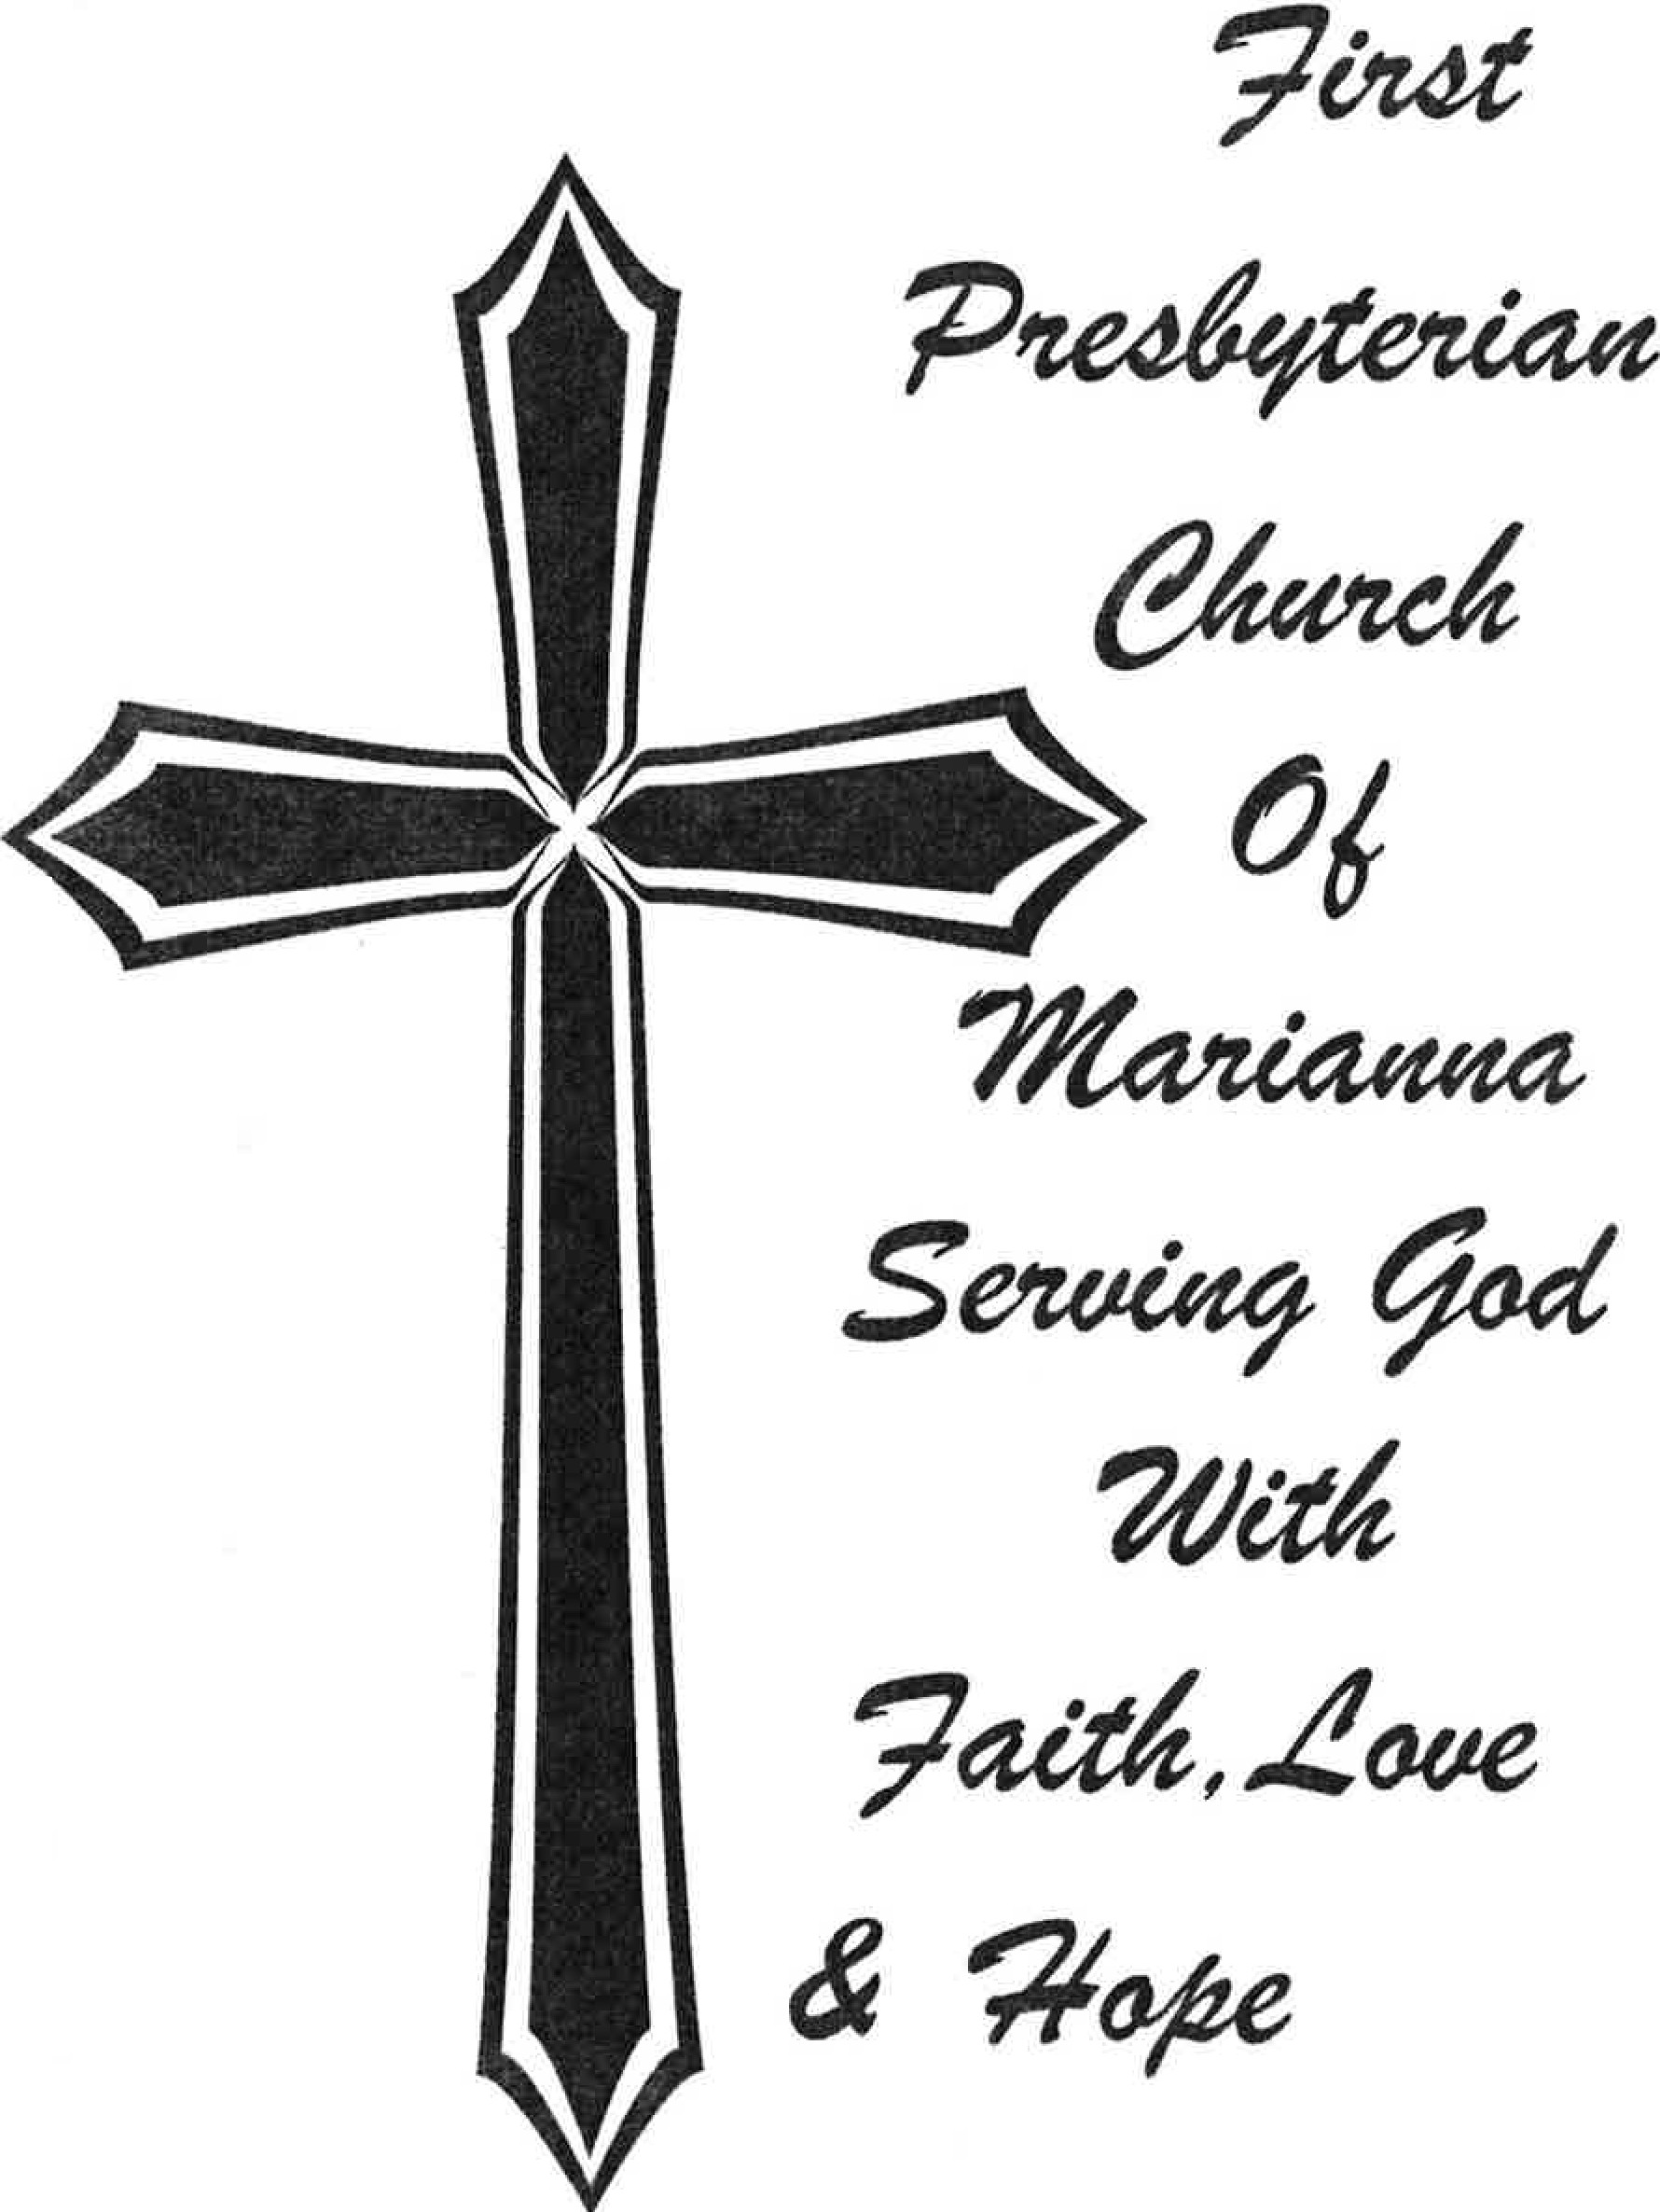
First Presbyterian Church Prays For:
(New requests in bold)
Marilyn Stadsklev King (Tom Stadsklev’s sister)
Family and Friends of Bill Homoney
Jake Gunter
Pam Fontenot (requested by Linda Wamsley)
Virginia Tinsley (Andy & Gina Tinsley’s daughter)
Mary Marden (Ernie McNeill’s sister-in-law)
Fred Carpenter
Doug Walker (Stanley Littleton’s brother-in-law)
Bobra Palmer (Bob Pitman’s sister)
Rosemary Parker (requested by Janie F. Pulliam)
Dot Carpenter
Don Morris
Tom Abney (Larry & Jackie Spivey’s son-in-law)
Roy Turner
Kay Trammell (Robert Trammell’s wife)
Steve Stafford (Barry’s dad)
Billy Herrington (requested by Jared Roberts)
Howard Alig (Cindy Morgan’s brother)
Steven Quigley
Hunter and Lu Daffin
Linda Bevis (requested by Mary Bevis Schmidt)
Matt Goold (requested by family)
Sybil Schmidt King (requested by Mary B. Schmidt)
Gail Stearn (Guy Green’s sister)
Destry Burch (requested by Mary B. Schmidt)
Ginny Rose, Brooke Grant, Malaki Grant
(Family of Carol and Dennis Maxson)
***************************************************
CHILDREN’S CHRISTMAS PAGEANT
6:00 pm this Wednesday, December 12th in the Sanctuary. This year’s title is “Sing A Song of Christmas”. Today the children will stay after Worship Service for lunch and rehearsal. Special thanks to Amanda Hinson and Flora Davis. The children are always super cute and you will be impressed with the music.

Come to the performance and stay after for salad and pizza.
You won’t want to miss this!
***************************************************
LOOKING AHEAD – MARK YOUR CALENDARS
Dec 10th - Sunday School Christmas Party at Jim’s Buffet; 5:30 pm
Dec 12th - Children’s Christmas Pageant
Dec 16th - Confirmation Class received and celebrated.
Dec 16th - Bell Choir Performance during Worship Service
Dec 16th - Joint Cantata FUMC at 6pm
Dec 17th - Lunch Bunch Meeting; Peggy Peacock’s; 11:30
Dec 24th - Christmas Eve Candlelight Communion Service; 6:00 pm
***************************************************

SINCE 1835

2898 Jefferson Street
Marianna, FL 32446
Phone (850) 526-2430
fpcmarianna@gmail.com
www.firstpresmarianna.org

